Session No# 24

Admin Screen: Jan 23rd, 2025

* In admin screen We have 2 schemes 1. **EmailScheme 2. SMSScheme**
* Whenever we select EmailScheme , we get the panel related information.A screenshot of a computer

  Description automatically generated
* When we select SMSScheme then we get the SMS related information.
* Schemes are nothing but offers on some panels, especially festival seasons GPM provide *offers* to customers to get an information and feedback on the products.
* Some schemes will be created and send an email to the particular panellist on particular panels.
* Also, we can add New Scheme for Emails and SMS to the GPM.
* We have 2 categories 1. **EmailCategory 2. SMSCategory**
* Generally, we have only one category list out under emailCategory & SMSCategory i.e *General Category.*

* Once we have configured in admin screen, it allows to select *General Category* option while sending an email in GPM .

* Based on the General Category we will get the templates to create emails and SMS.

* **Add Reasons:** we can create reasons and add it to GPM and it will use where it is required.
* **Subject Mapping:** Here we configure an email subject based on the Scheme, Subject, Action Code and Category.

* **WhatsApp Templates**: here we can create and configure the templates, it will be available in GPM to send whatsapp messages.

* **Consent Screen**: The main intention for this, is the panellist ready to give data or not on the product.
* This feature is only implemented for *France country* only.
* To create consent form, we need use Consent type, consent Method, consent status, consent validity and Consent Scope.

Consent type: The panellist which way to give consent , like facebook,

Consent Method: Would be Phone, Web, Paper…

consent status: would be Yes, No and undeclared.

consent validity: what is the validity for particular consent whether 13 months or 24 months or 36 months.

**To create a Consent Form:**  In France go to CommunicationsàConfigurationàConsentForms.

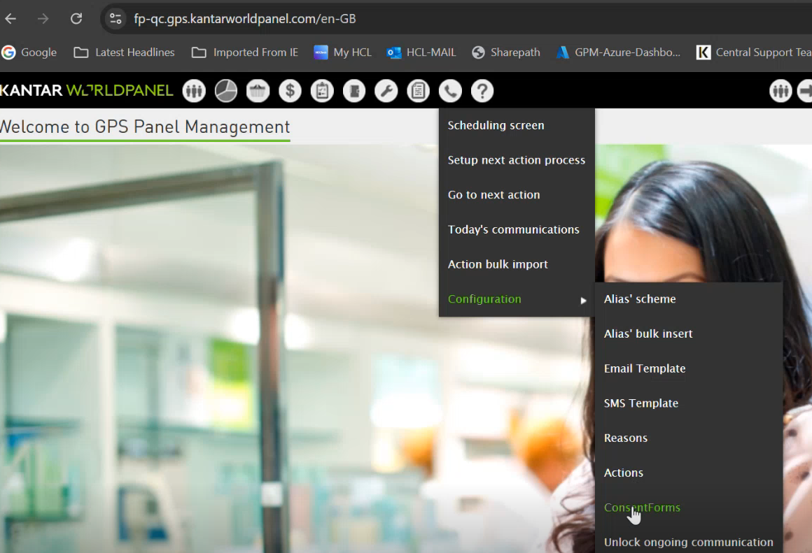

* While creating the Consent Form we need to fill below mandatory fields and save it.

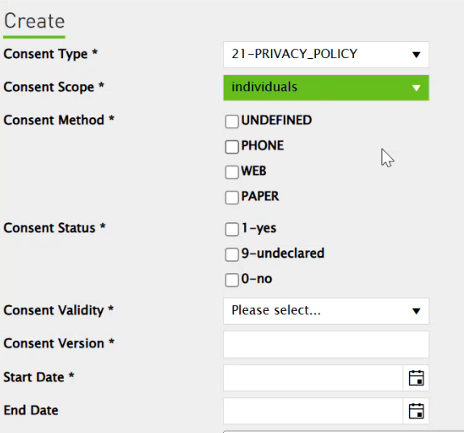

* **Add Products**: Here we can add the product Brands to GPM.
* **Domain Names:** This is especially built for France, they want to know which domain they are using.
* **Add Product Answers & Product Answer Mapping:** These answers are using for demanded products in market from panellist.

* **External Mapper:** The users are importing the data through SSIS imports, for that they need to create External Mapper, so based on this they need to create the import file by using source Field, Description, Target Field.

* SSIS related issues we can check here.
* By using External Mapper, where can configure different types of imports it collects all panellist information like your address, your first name, your last name, your demographic information's.
* We pull the millions of data into GPM using this external mapper.